Calculator Assumed
Topic: Mixed Trigonometry Applications

Time: 45 minutes
Total Marks: 45
Your Score: / 45



Question One: [5 marks]

The area of an obtuse isosceles triangle with equal side lengths of 12 cm is .

Determine the length of the third side.

Question Two: [3 marks]

Prove that
Question Three: [6 marks]

Show, with algebraic reasoning, that

Question Four: [6 marks]

A and B are both acute angles such that and .
Determine the exact value of

Question Five: [8 marks]

Calculate the area of the shaded region if it is known that the length of AB is 5 cm.

Question Six: [1, 6, 4 = 11 marks]

A cyclic quadrilateral, ABCD, has , , and .
Calculate:

- the size of angle .

- the size of angle .

- the area of the quadrilateral.

Question Seven: [4, 2 = 6 marks]

A Ferris wheel has a diameter of 40m, with the centre 22m above the ground.
Customers riding the Ferris wheel, climb a few stairs and get on a carriage at the lowest point of the wheel.
The wheel makes one rotation every 120 seconds.

- Draw a sketch of one rotation of the Ferris wheel from when a customer steps onto the ride.

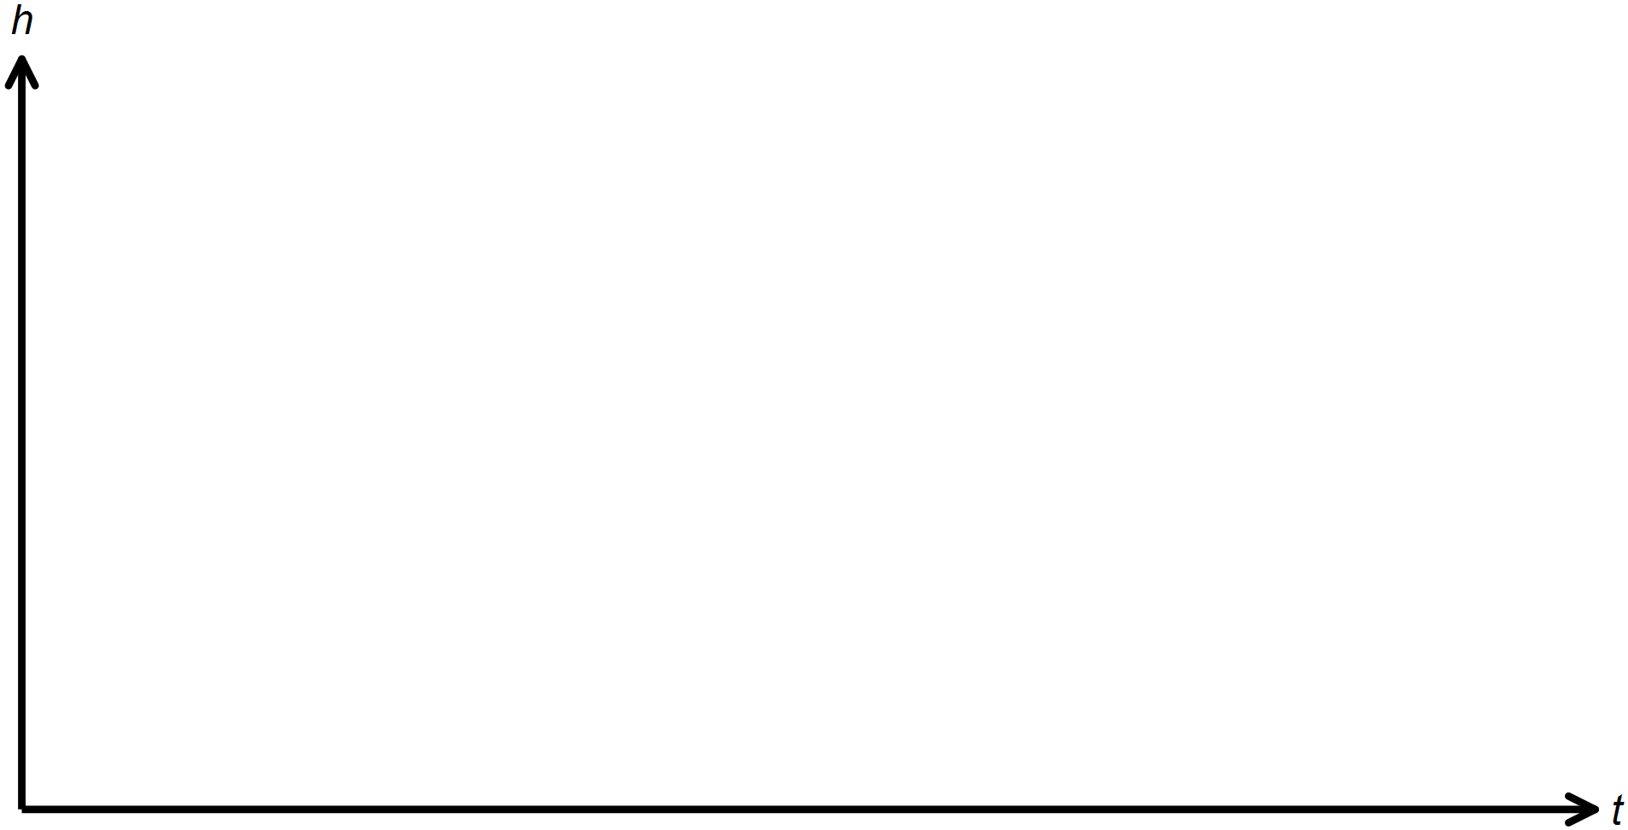

- Hence or otherwise find the cosine equation of the graph.

SOLUTIONS
Calculator Assumed
Topic: Mixed Trigonometry Applications

Time: 45 minutes
Total Marks: 45
Your Score: / 45



Question One: [5 marks]

The area of an obtuse isosceles triangle with equal side lengths of 12 cm is .

Determine the length of the third side.







Question Two: [3 marks]

Prove that




Question Three: [6 marks]

Show, with algebraic reasoning, that







Question Four: [6 marks]

A and B are both acute angles such that and .
Determine the exact value of






Question Five: [8 marks]

Calculate the area of the shaded region if it is known that the length of AB is 5 cm.












Question Six: [1, 6, 4 = 11 marks]

A cyclic quadrilateral, ABCD, has , , and .
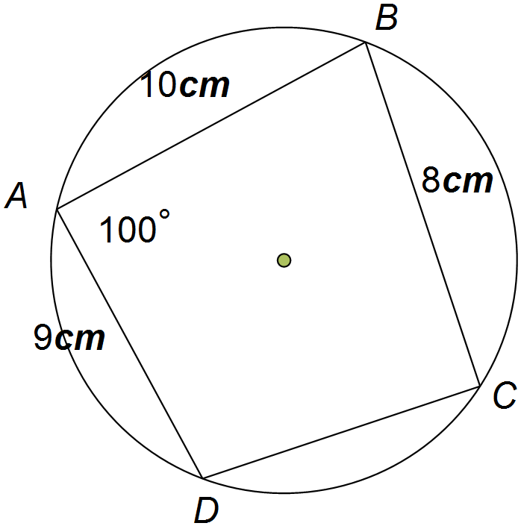Calculate:

- the size of angle .



- the size of angle .








- the area of the quadrilateral.




Question Seven: [4, 2 = 6 marks]

A Ferris wheel has a diameter of 40m, with the centre 22m above the ground.
Customers riding the Ferris wheel, climb a few stairs and get on a carriage at the lowest point of the wheel.
The wheel makes one rotation every 120 seconds.

- Draw a sketch of one rotation of the Ferris wheel from when a customer steps onto the ride.

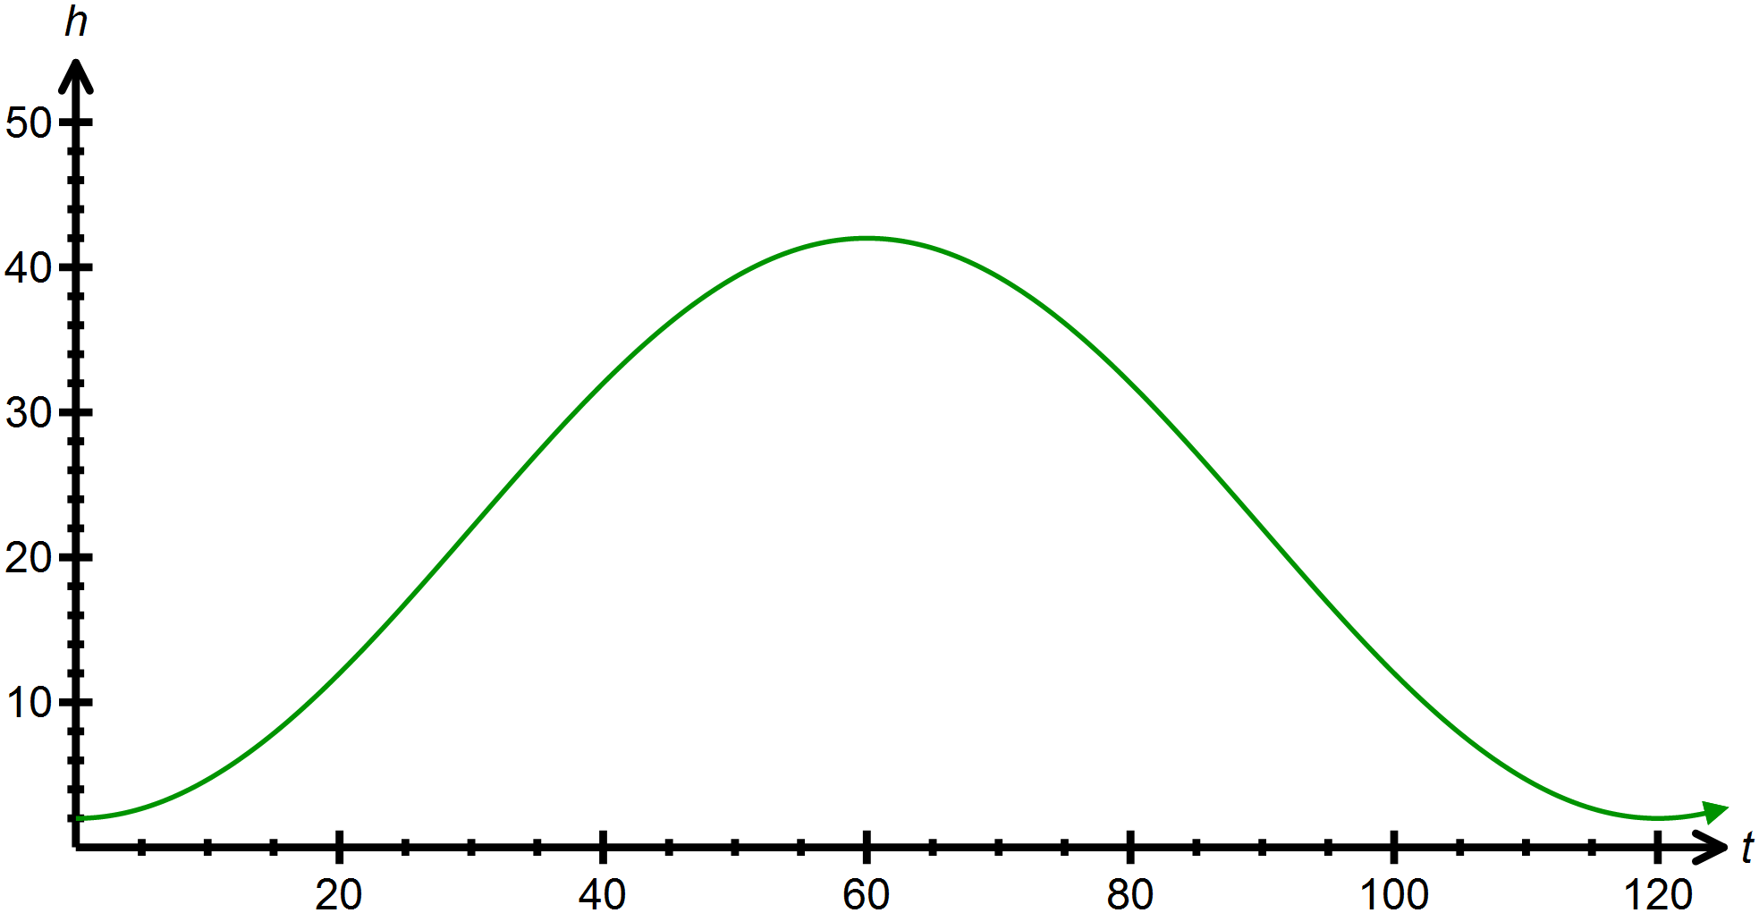








- Hence or otherwise find the cosine equation of the graph.




